SHIELDGUARD INC. - SECURE NETWORK TOPOLOGY ( SUMMARY)
Objective: Design a secure, scalable network for a small office that enables segmented access for employees, guests, and internet-facing services.

Network Zones & Addressing:
Zone | VLAN | Subnet | Interface
Inside LAN | 10 | 192.168.10.0/24 | GigabitEthernet0/1
Guest Wi-Fi | 20 | 192.168.20.0/24 | GigabitEthernet0/2
DMZ | 30 | 192.168.30.0/24 | GigabitEthernet0/3
Outside | — | 203.0.113.0/24 | GigabitEthernet0/0

Security Features:
- Firewall (Cisco ASA): Defines security levels: inside (100), guest (50), dmz (25), outside (0)
- Access Control Lists (ACLs):
- Inside LAN → Permit all
- Guest → Deny access to Inside LAN
- Outside → Permit HTTP/HTTPS to DMZ
- NAT Rules:
- Inside & Guest to Internet: PAT
- Static NAT for DMZ Web Server (203.0.113.2)

Wireless Configuration:
- SSIDs: Office_WiFi (VLAN 10), Guest_WiFi (VLAN 20)
- WPA2 Encryption, strong passwords
- VLAN tagging enabled

Testing Summary:
- Office to Internet ✅
- Guest to Internet ✅
- Guest to Office ❌ (Blocked)
- Outside to Web Server ✅
- VLAN Isolation ✅
Conclusion: This setup ensures strong segmentation, secure internet access, public-facing services via DMZ, and future scalability. Ideal for modern small office needs.
Prepared by: [Your Name]
Date: [Insert Date]
Network Topology Diagram
Below is a visual representation of the secure network design:
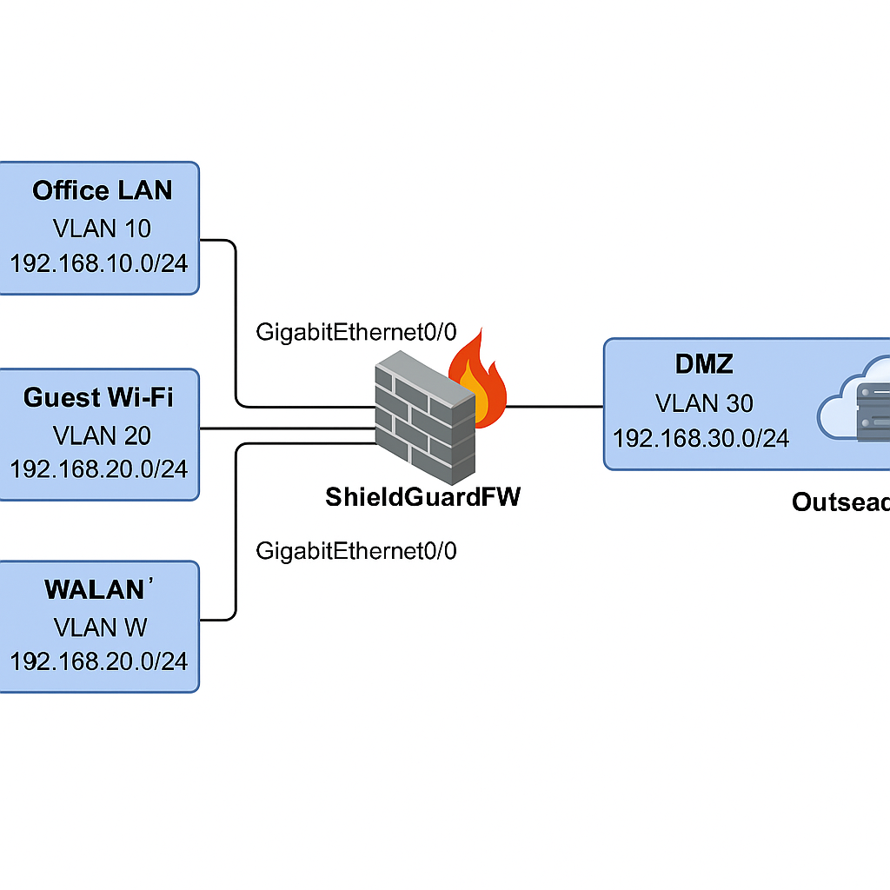Cisco ASA CLI Firewall Configuration Examples
! OUTSIDE Interface
interface GigabitEthernet0/0
nameif outside
security-level 0
ip address 203.0.113.1 255.255.255.0
no shutdown
! INSIDE Interface
interface GigabitEthernet0/1
nameif inside
security-level 100
ip address 192.168.10.1 255.255.255.0
no shutdown
! GUEST Interface
interface GigabitEthernet0/2
nameif guest
security-level 50
ip address 192.168.20.1 255.255.255.0
no shutdown
! DMZ Interface
interface GigabitEthernet0/3
nameif dmz
security-level 25
ip address 192.168.30.1 255.255.255.0
no shutdown
! Access Rules
access-list inside_access_in extended permit ip any any
access-group inside_access_in in interface inside
access-list guest_access_in extended deny ip any 192.168.10.0 255.255.255.0
access-list guest_access_in extended permit ip any any
access-group guest_access_in in interface guest
access-list outside_access_in extended permit tcp any host 192.168.30.2 eq 80
access-list outside_access_in extended permit tcp any host 192.168.30.2 eq 443
access-group outside_access_in in interface outside

Testing & Validation
Test Cases Conducted:
- Ping from Inside LAN to Internet: Success
- Ping from Guest Wi-Fi to Internet: Success
- Ping from Guest to Inside: Blocked (Expected)
- Web access from Outside to DMZ (HTTP/HTTPS): Success
- Confirmed VLAN isolation using traceroute and ping between zones
- Verified NAT translation and ACLs using ASA 'show nat', 'show access-list'
Conclusion:
All configured zones function independently with strict firewall segmentation. The implementation was validated against expected behavior for each test case.

Scalability Considerations
This design can scale by:
- Adding new VLANs on the managed switch for additional departments
- Defining new NAT/PAT rules for expanded internet access
- Adding more DMZ services using static NAT mappings
- Leveraging ASA object groups for simplified ACL management

